LAB Logbook
Lab 1
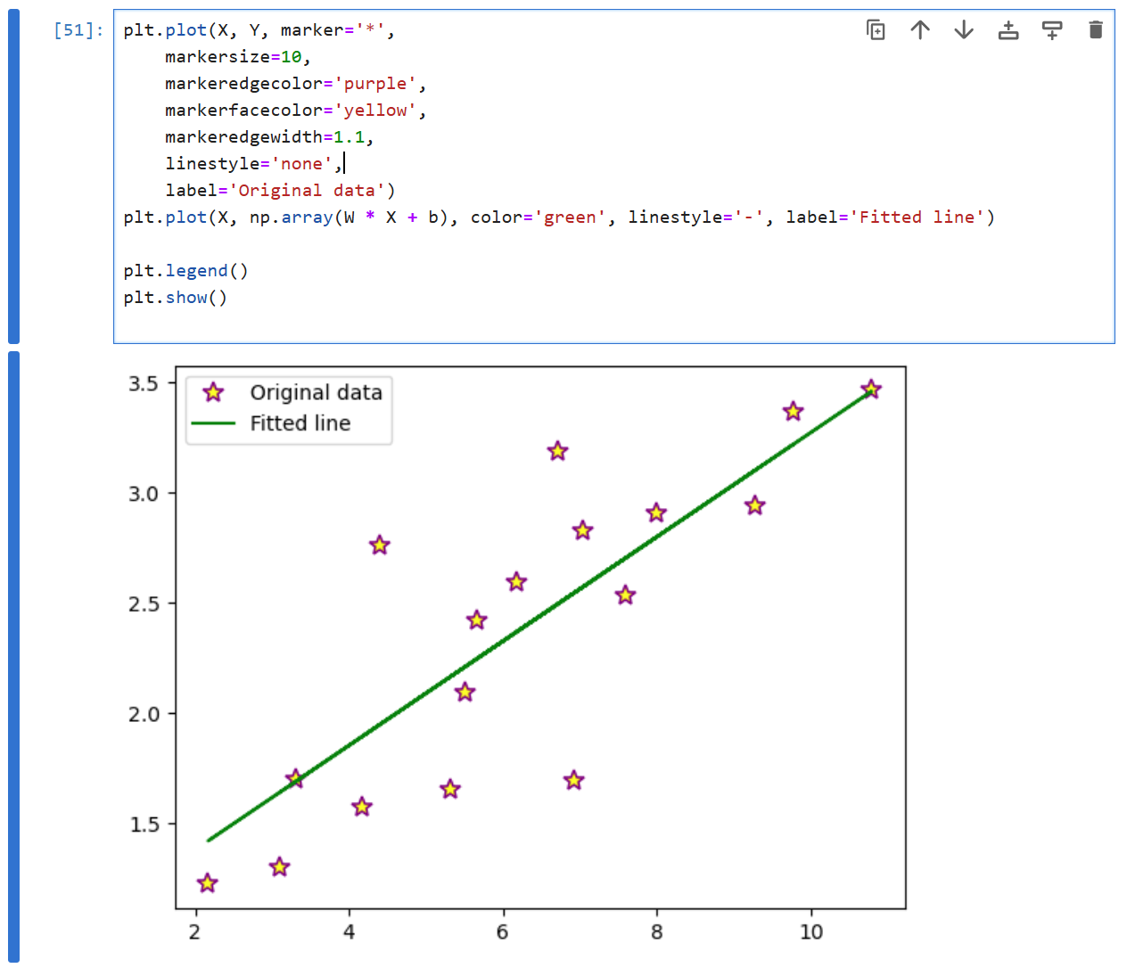
Lab 2
1.
Training Accuracy: 0.97
Test Accuracy: 0.94
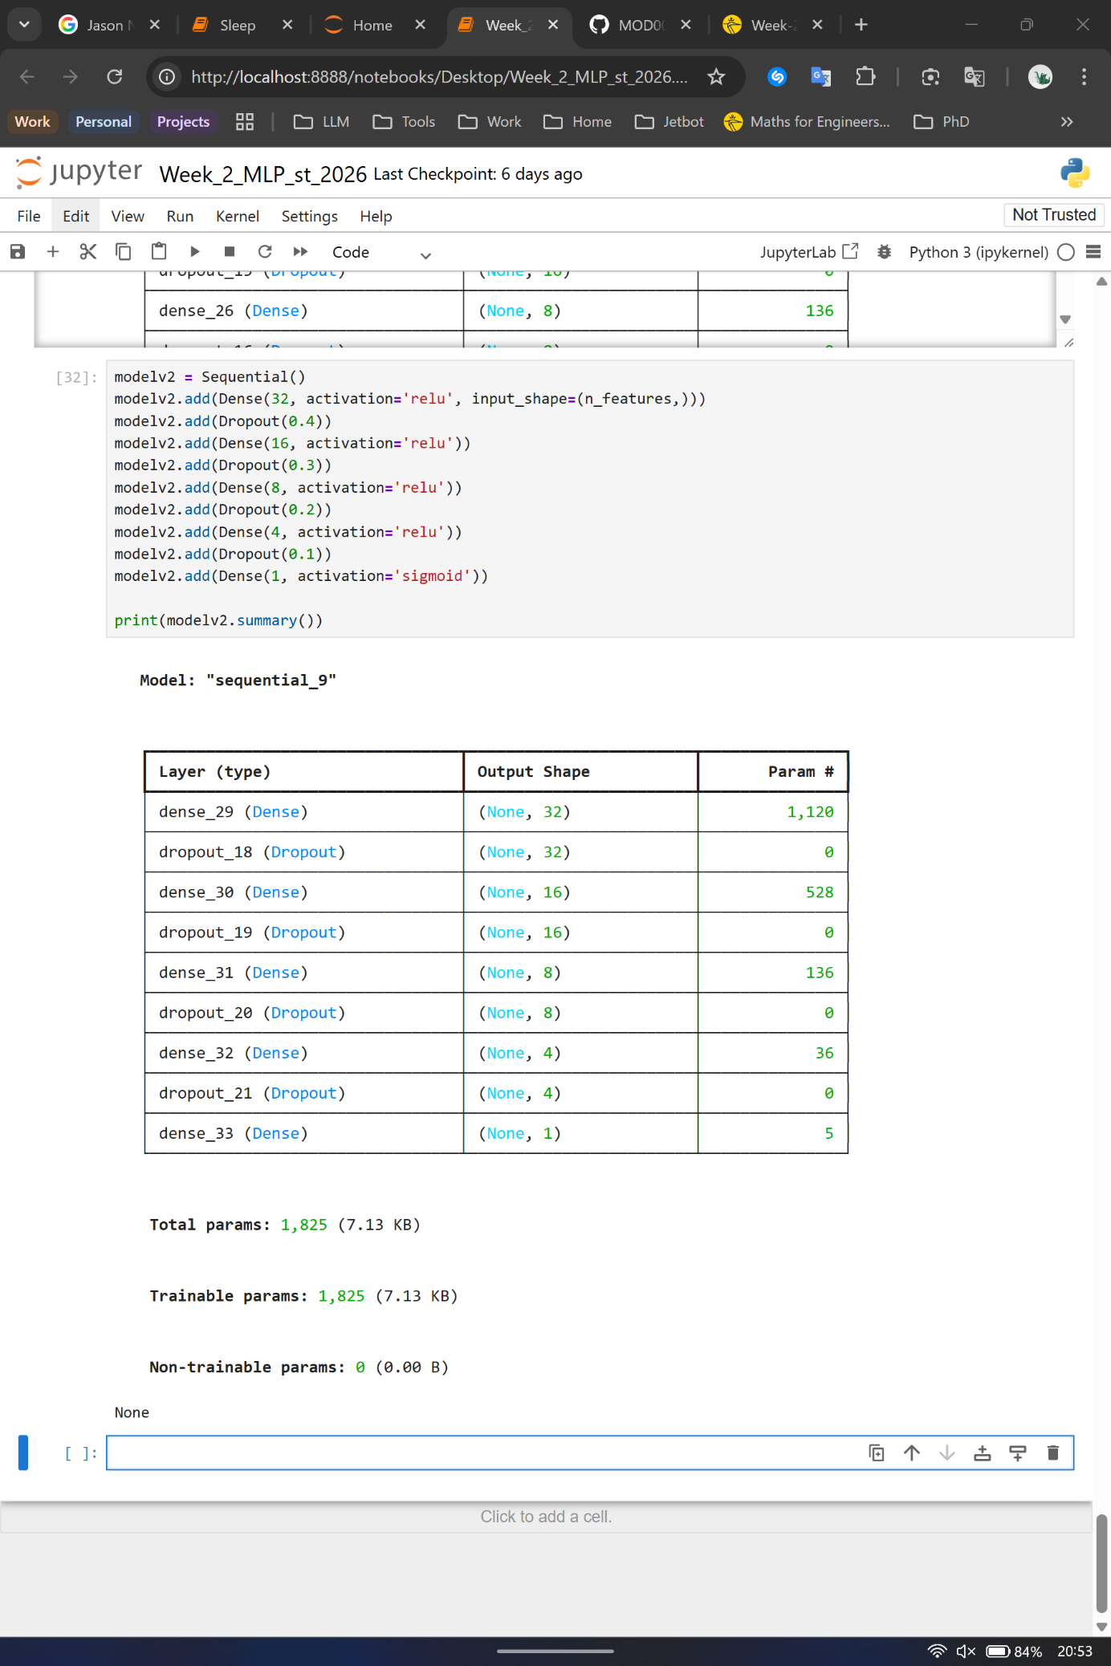
2.
3.
O1: 1.808
O2: 1.808
Lab 3
Training Accuracy: 0.99
Test Accuracy: 0.89
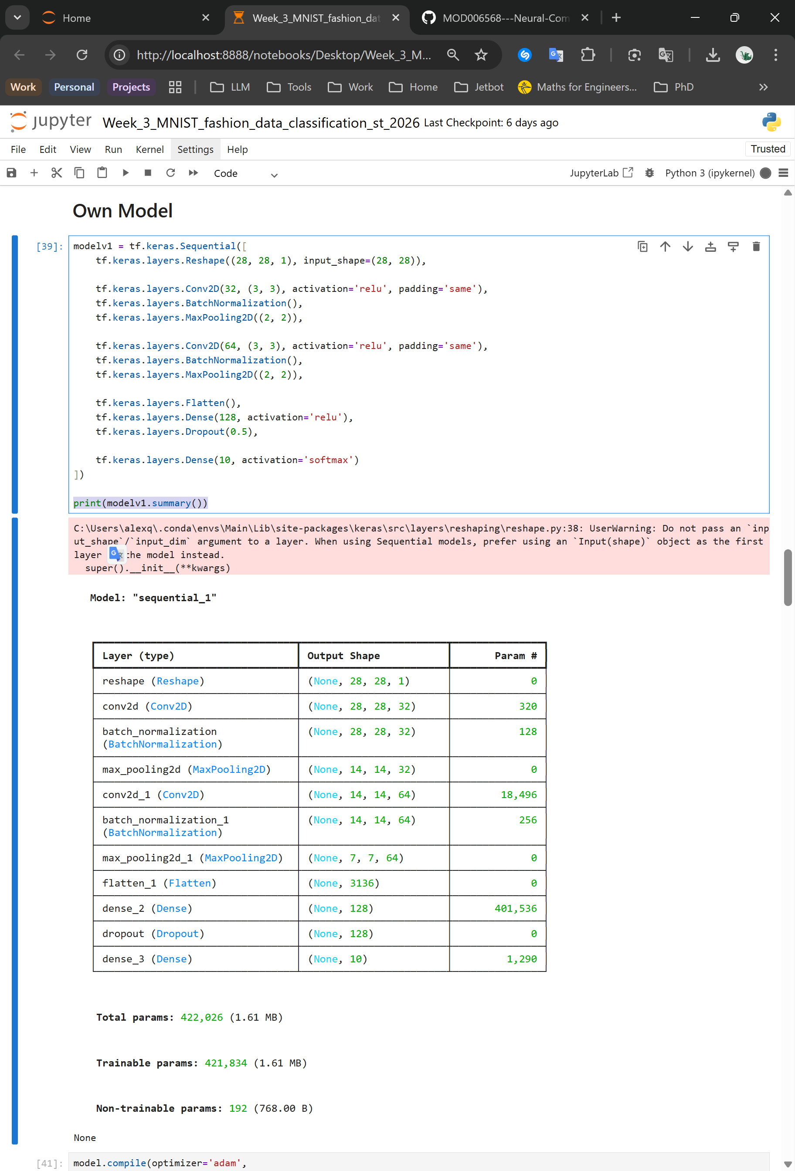
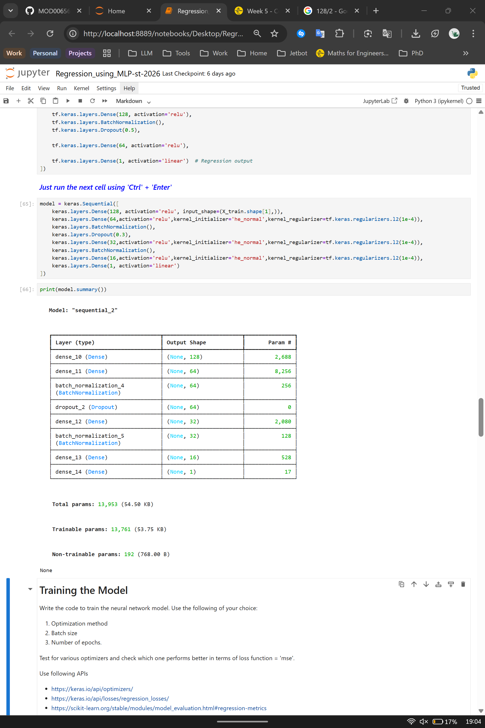
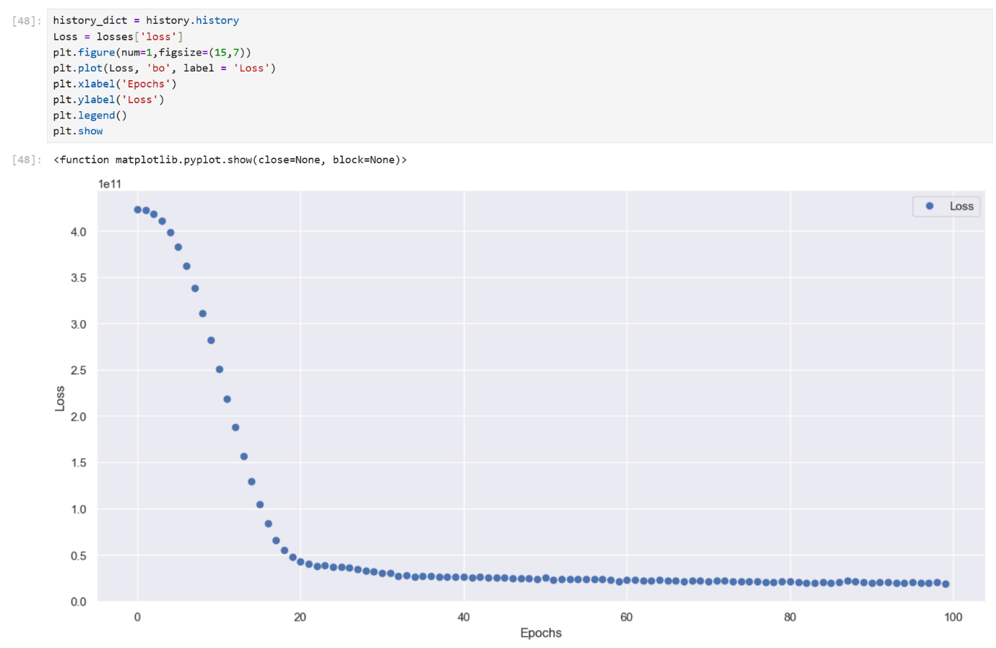
Lab 4
Lab 5
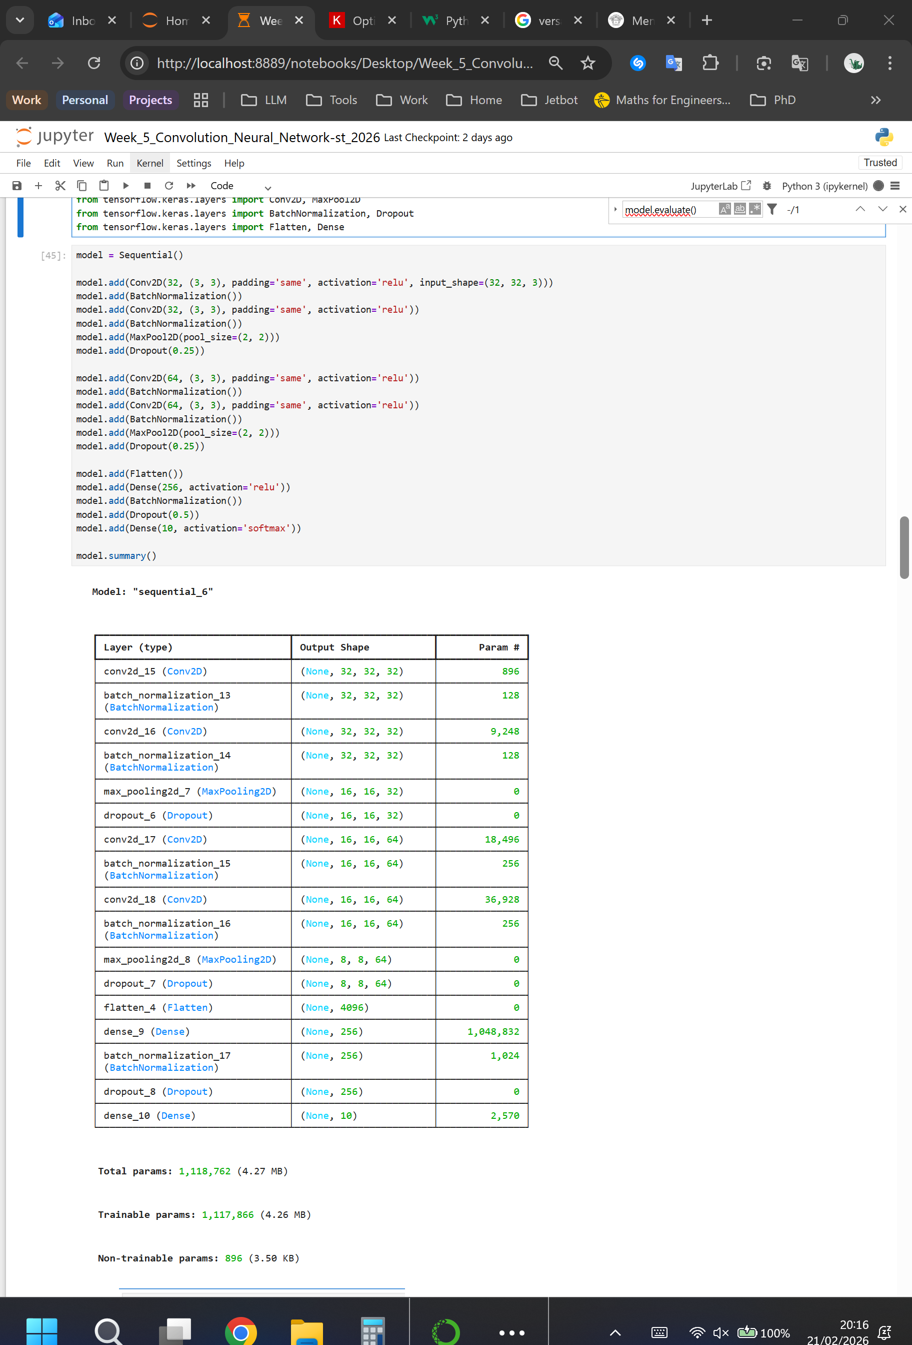
1.

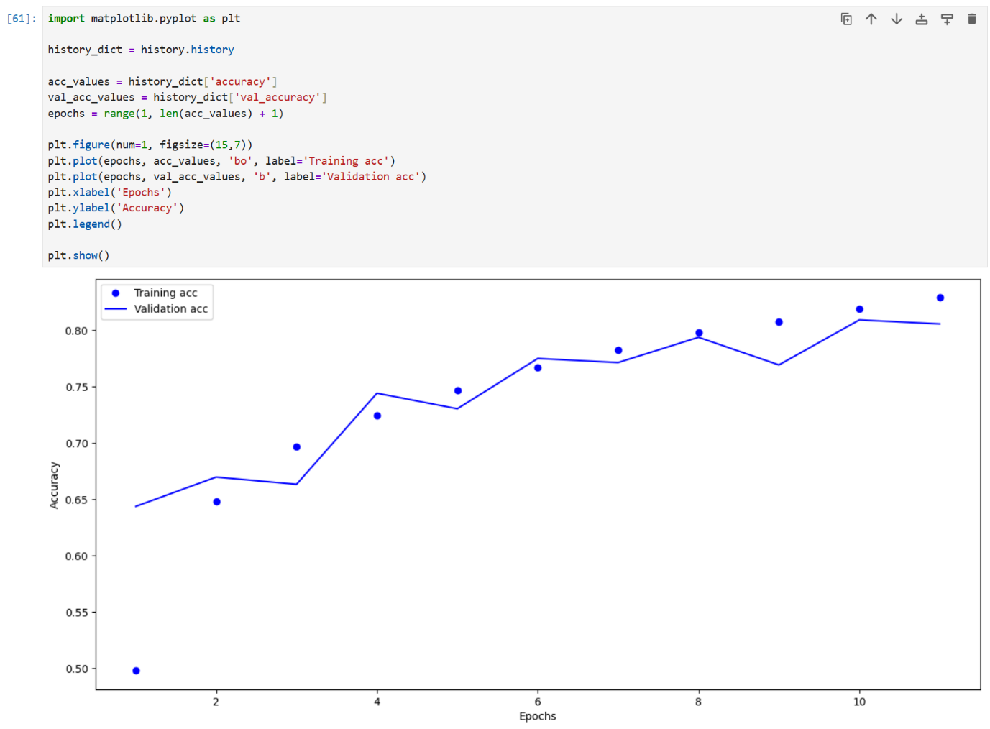
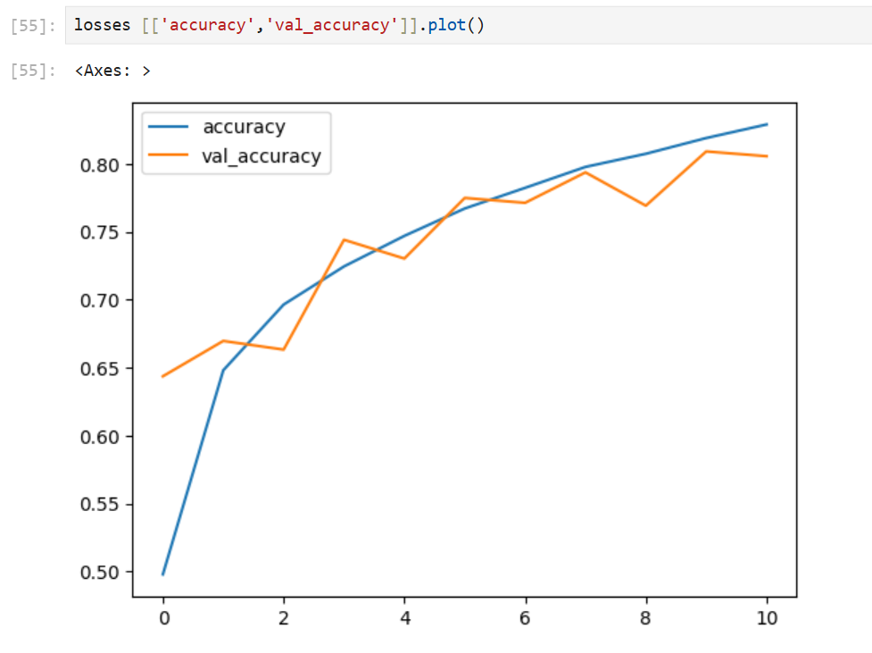
2.

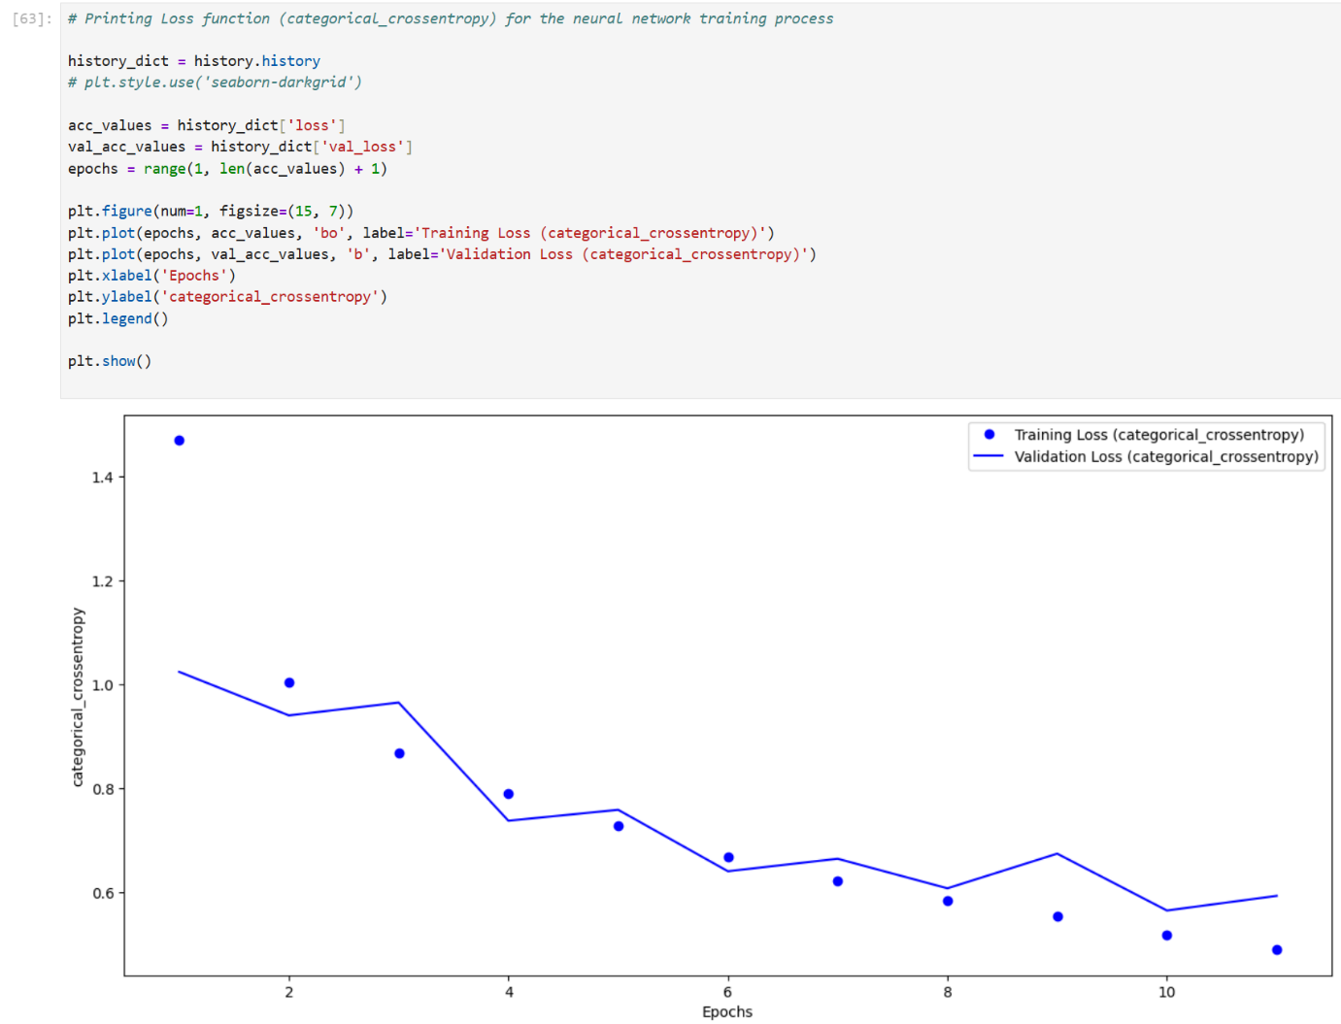
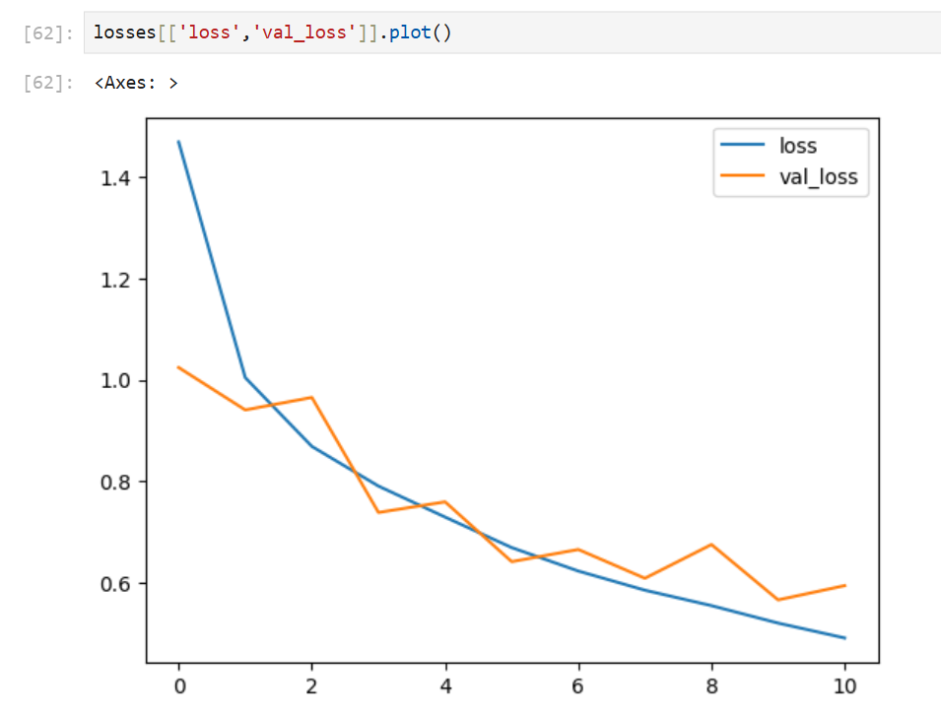

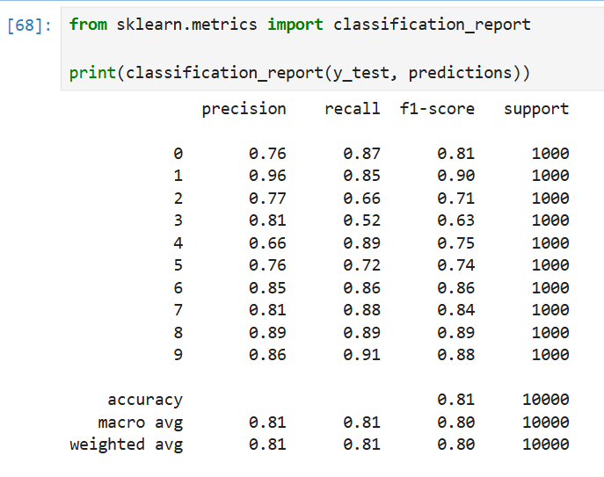
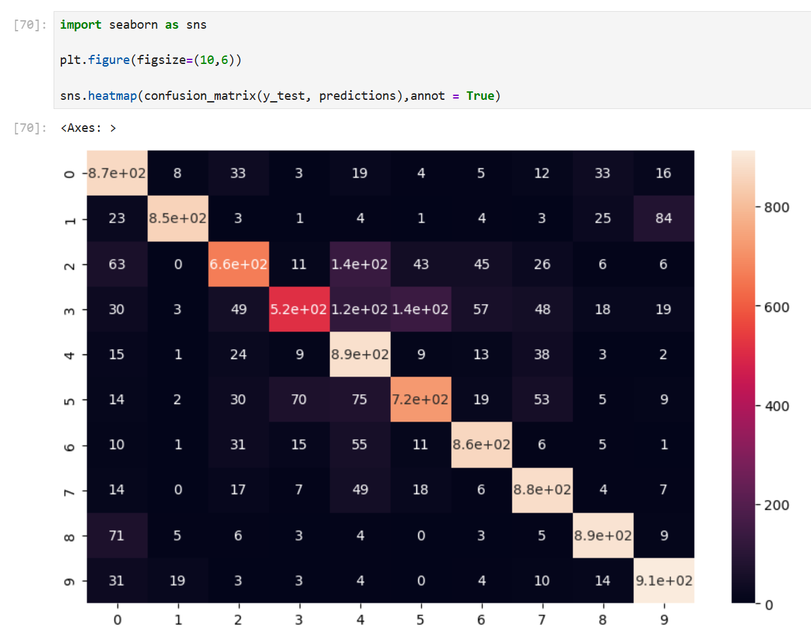

3.
The four graphs above indicate that no overfitting has occurred yet. During a few epochs, there were notable spikes in Validation Loss and notable drops in Validation Accuracy. These always balance themselves out in the following epoch. To detect overfitting, more epochs would have been needed to obtain unambiguous results.
4. (Optional Task)
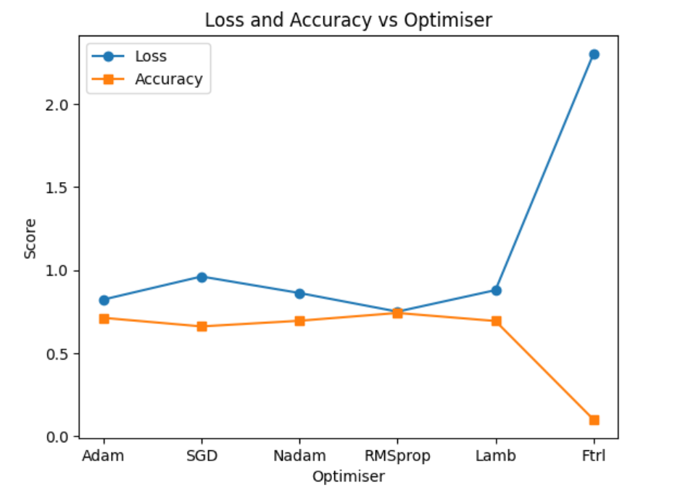
Loss and Accuracy of different Optimiser after three epochs:

Lab 6
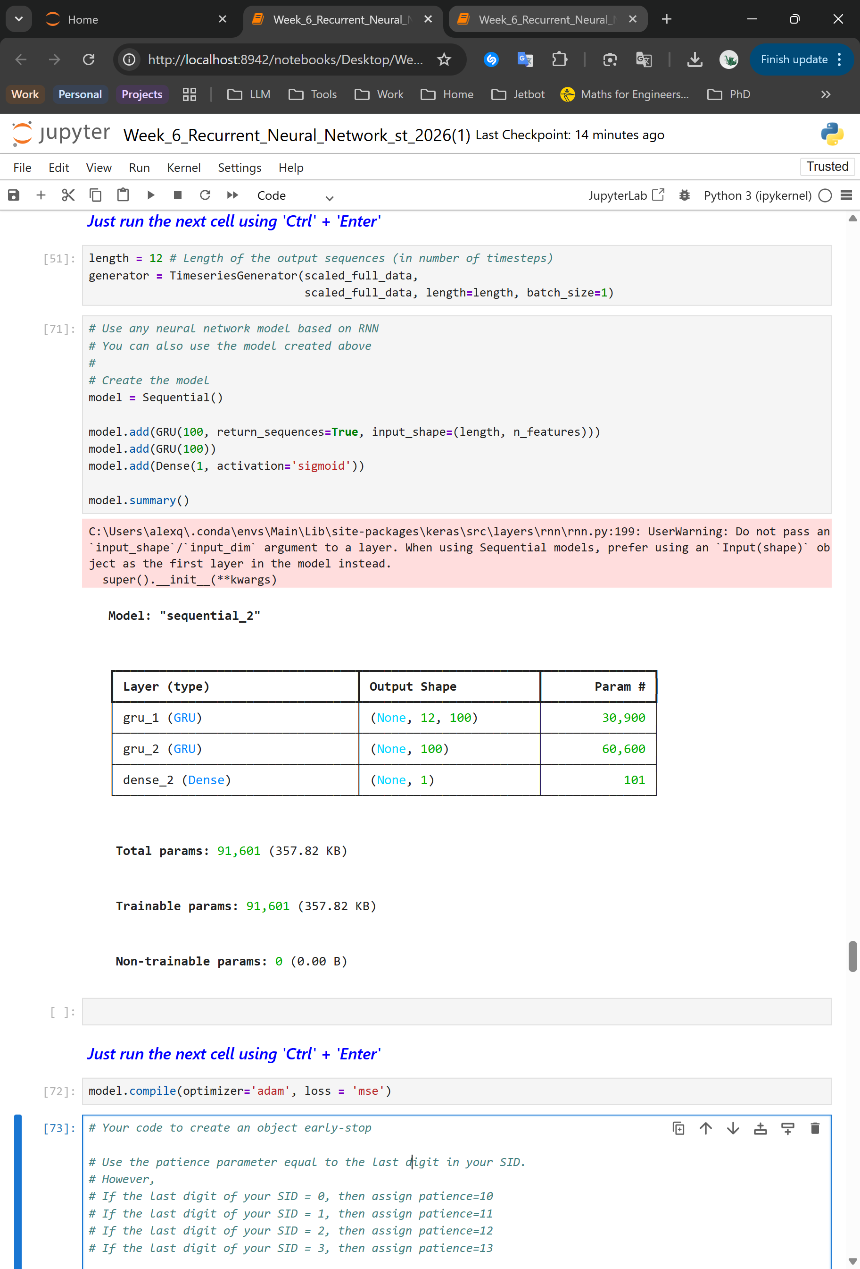
1.

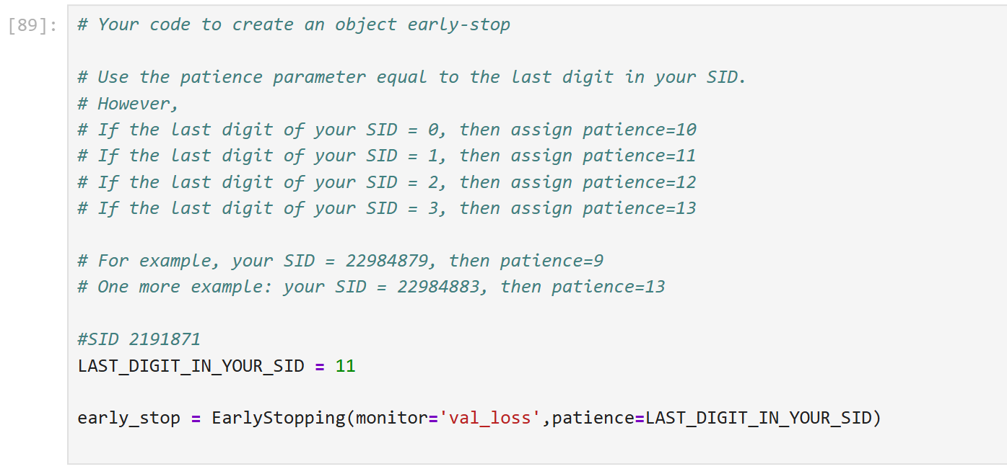
2.

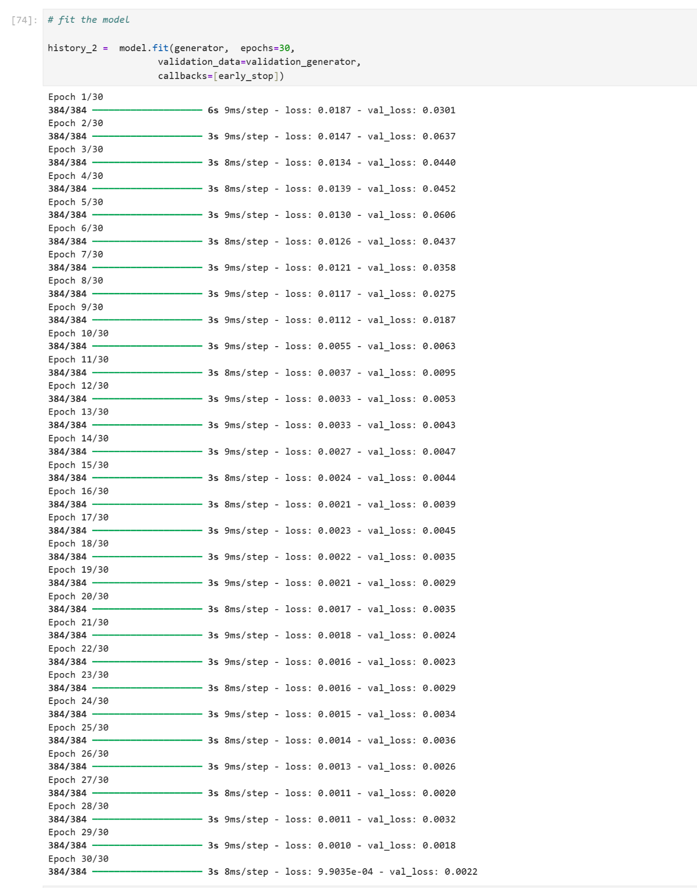

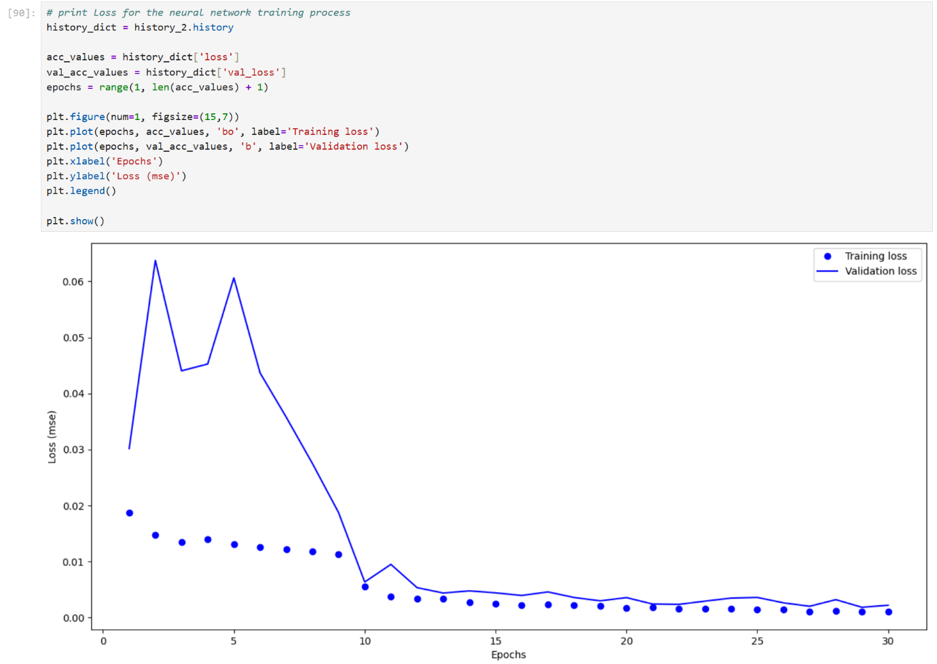
3.

4.
In the graph above, the validation loss stagnates starting from epoch 12. Therefore, everything after epoch 13 could be considered overfitting. Although epoch 27 achieves the lowest validation loss overall in the training, this minimum is negligible due to the incredibly close low validation loss at epoch 13 (<0.01 & >0.00).

5.
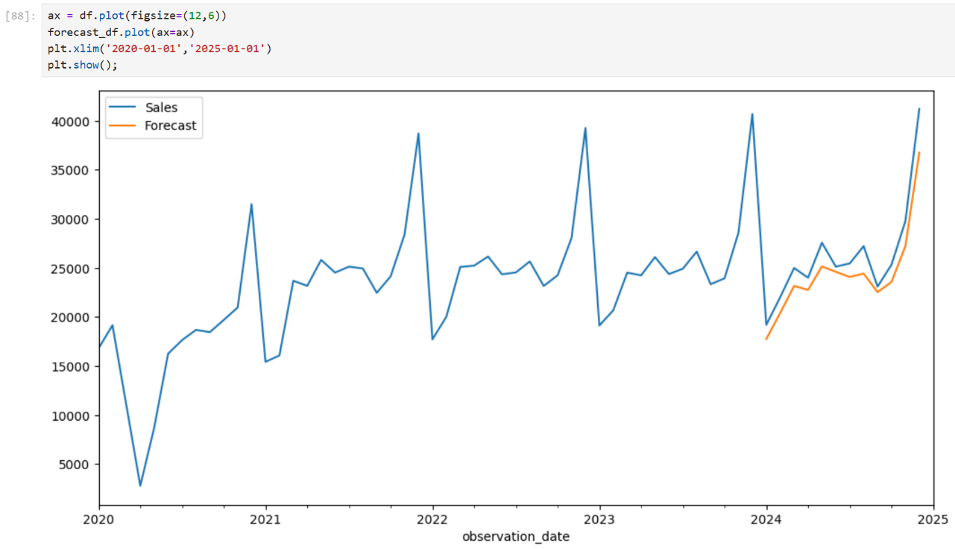

6. (Optional Task)
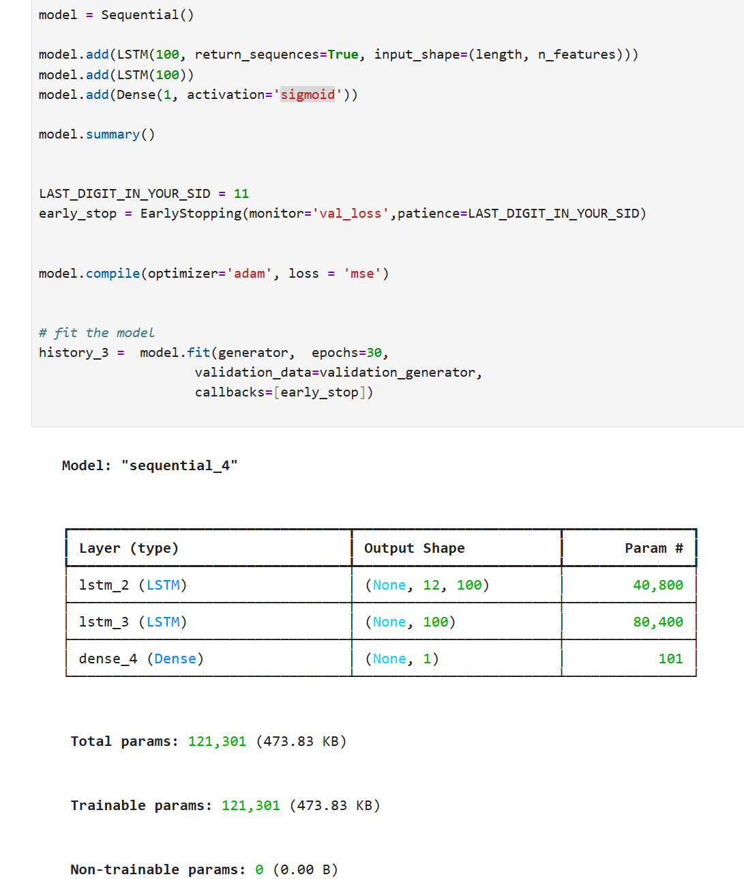

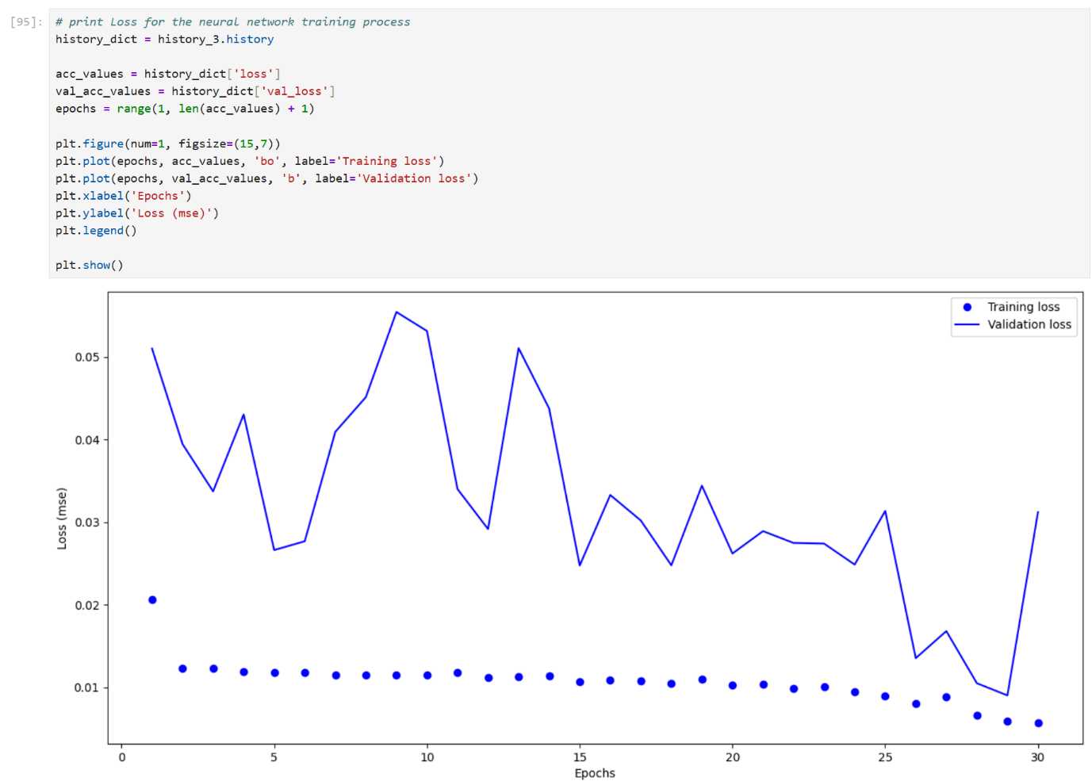
Training was very unstable with the same setup as history_2 training.

Lab 7
1.
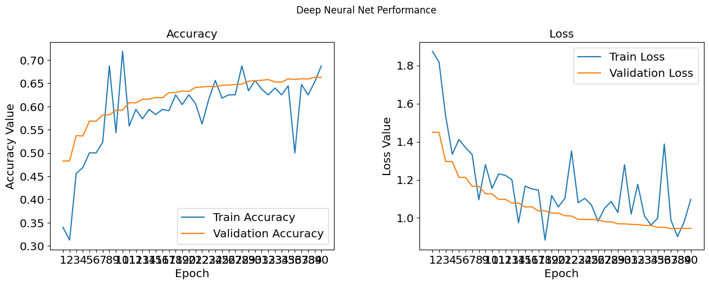
VGG16:

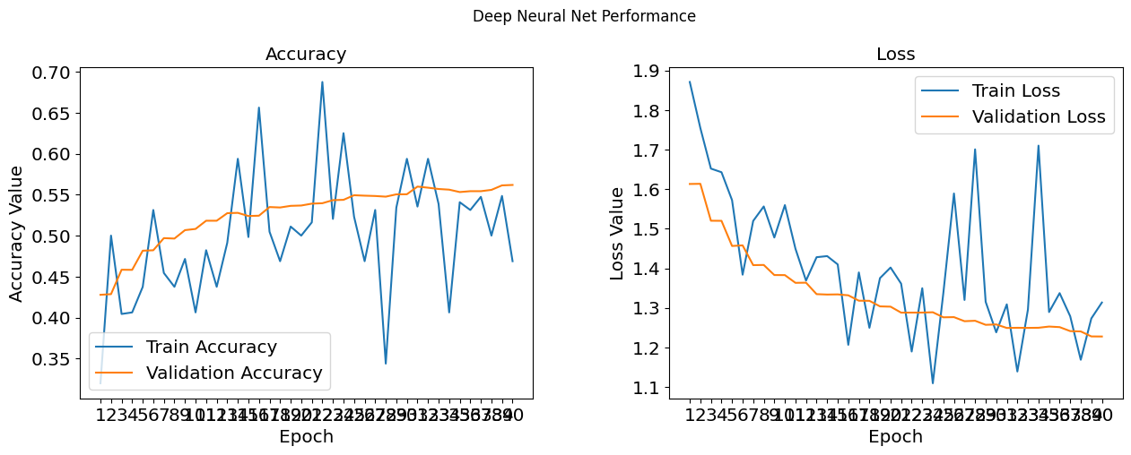
VGG19:

2.
VGG16: The validation accuracy increases until 30-35 and then plateaus around 0.66. The validation loss continues decreasing slowly until 38-40. So, the optimal number of epochs is around 35-38 epochs but more training might indicate more clearly what the optimal number of epochs is.
VGG19: The validation accuracy plateaus around 0.54-0.56 after 25 epochs. The validation loss minimum around 30-33 then slightly increases. So, the optimal number of epochs is around 30-33 epochs but more training might indicate more clearly what the optimal number of epochs is.

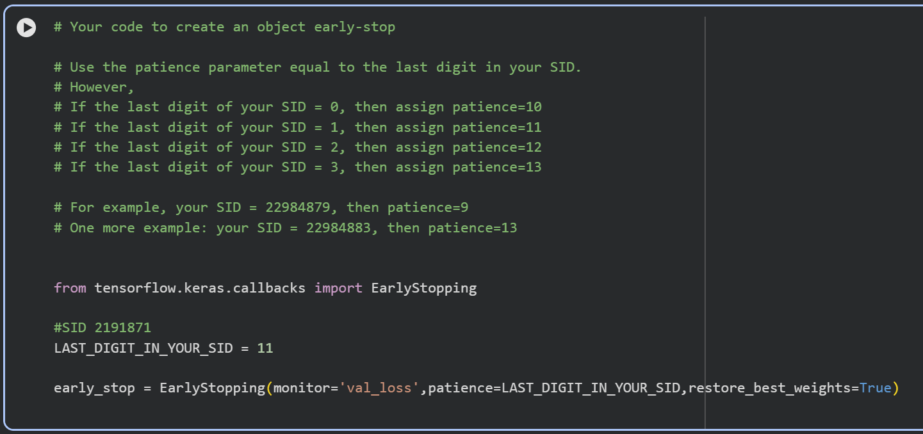
3.

4.
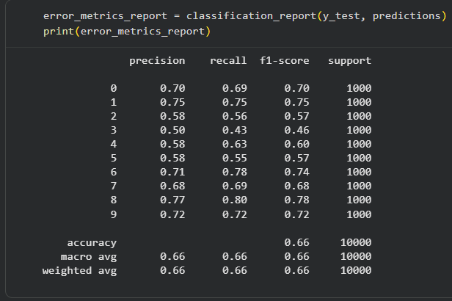
VGG16:

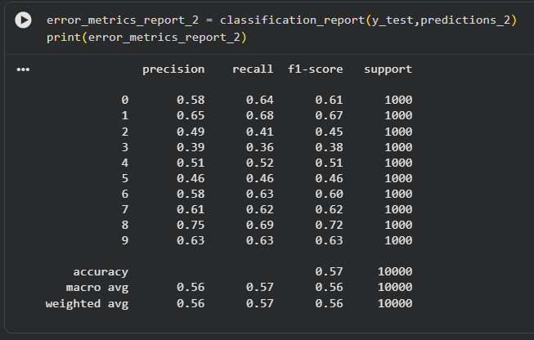
VGG19:

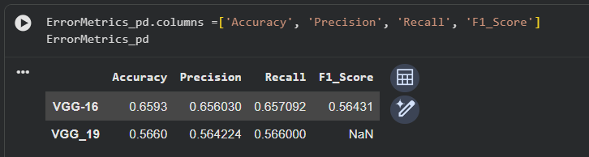
Table:
5.
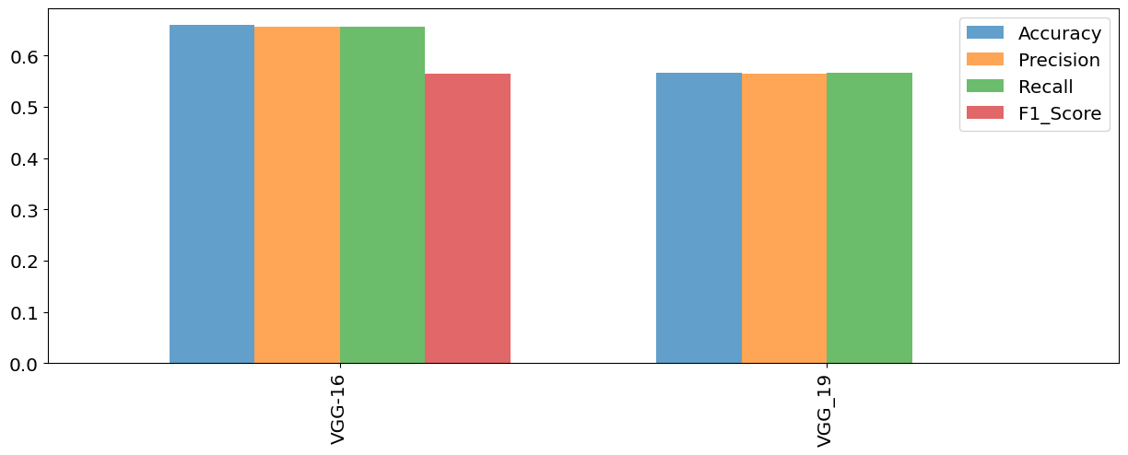

6. (Optional Task) Inception V3
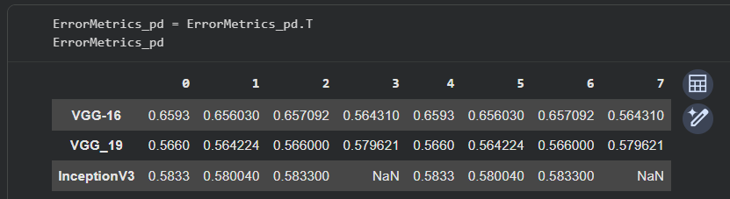
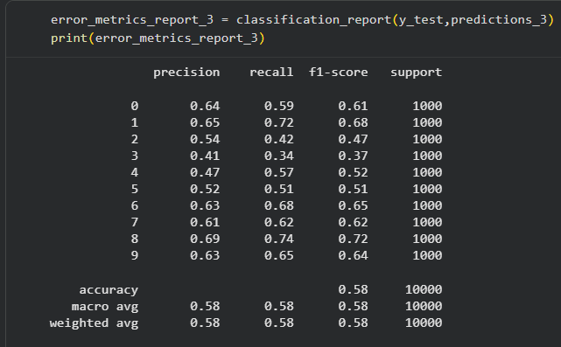
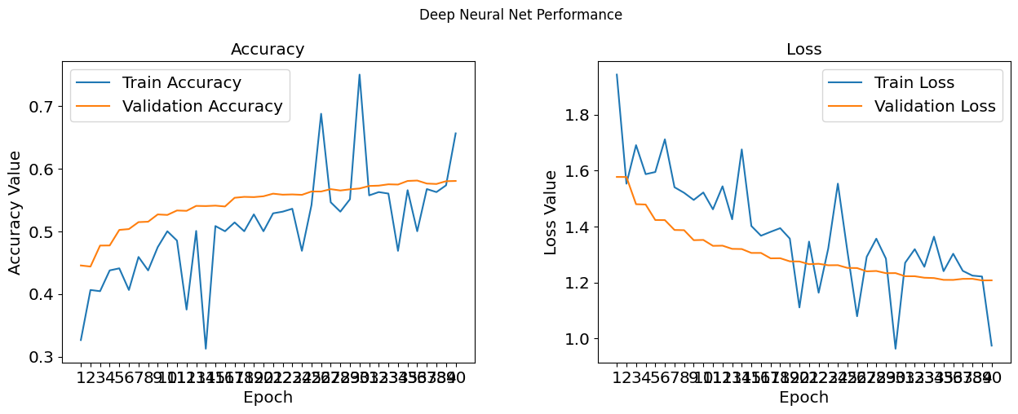

(fixxed missing values later in the code)

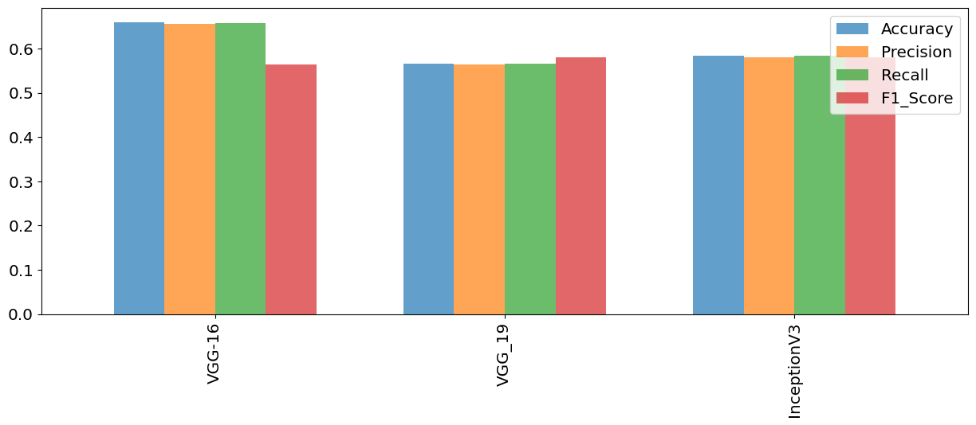
Performance comparison with fixed missing values

Lab 8

Lab 9

Lab 10

Lab 11

Lab 12

